30.30: (a) Energy conservation says 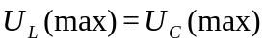
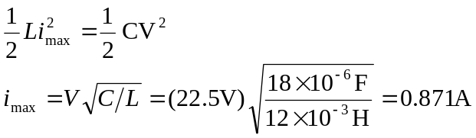
The charge on the capacitor is zero because all the energy is in the inductor.
(b)
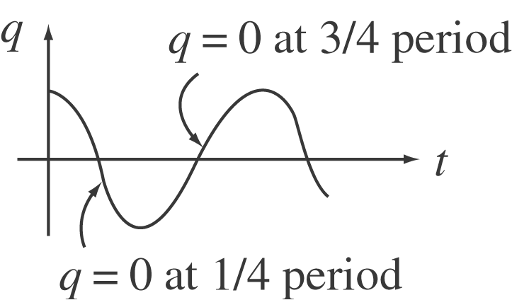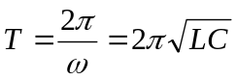
at 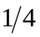 period: 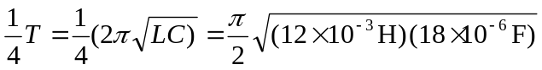
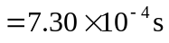
at 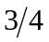 period: 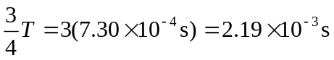
(c) 